**Lab No: 8 Form Processing using Django – Part II**

**Name: Ketan Goud**

**Reg No: 220905260**

**Section: D D2**

**Roll No: 39**

**1. Create a Register page and Success page with the following requirements:**

**i. Register page should contain four input TextBoxes for UserName, Password, Email id and Contact Number and also a button to submit. Make the username as compulsory field and other fields as optional.**

**ii. On button click, Success page is displayed with message "Welcome {UserName}" and also his Email and Contact Number has to be displayed.**

**iii. Use secure technique to send details to the Success page (Hint: use csrftoken) Design a website with two pages.**

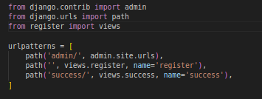

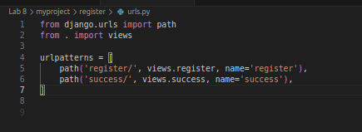

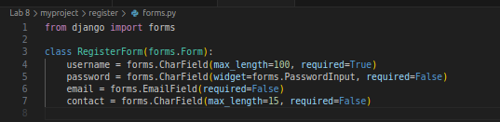

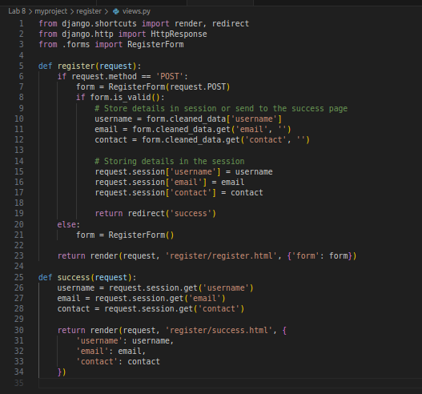

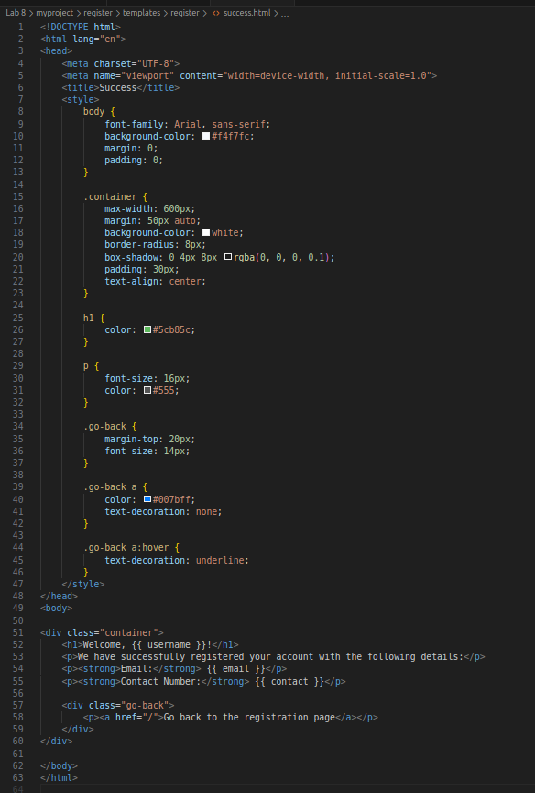

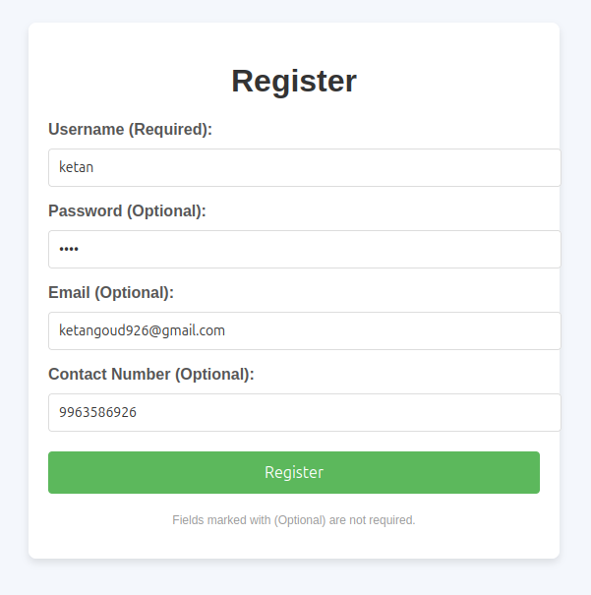

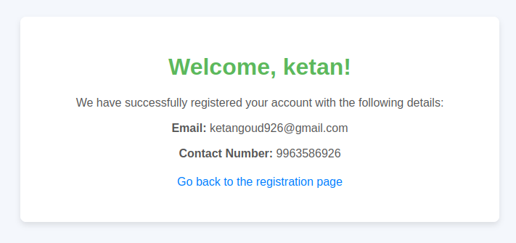

**2. “How is the book ASP.NET with c# by Vipul Prakashan?” Give the user three choice: i) Good ii) Satisfactory iii) Bad. Provide a VOTE button. After user votes, present the result in percentage using labels next to the choices**

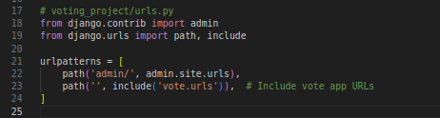

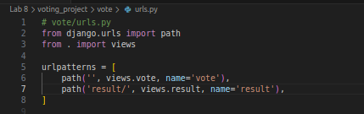

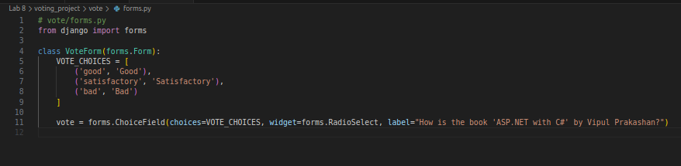Vote.html

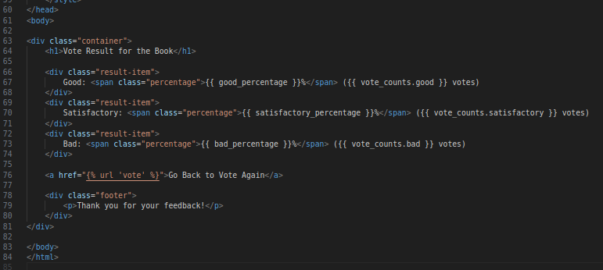

Result.html

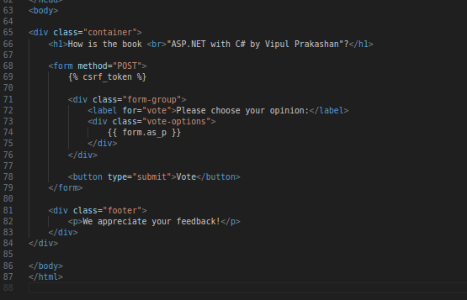

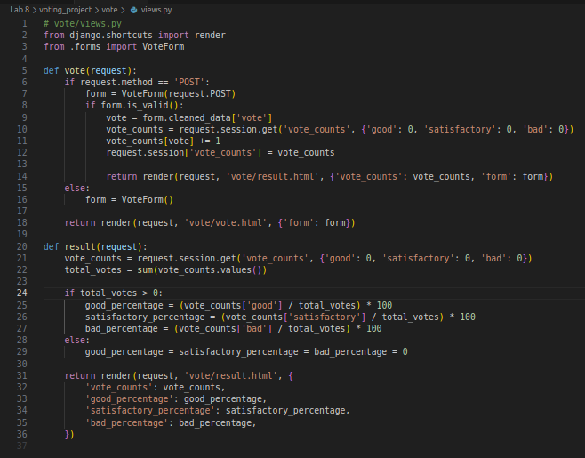

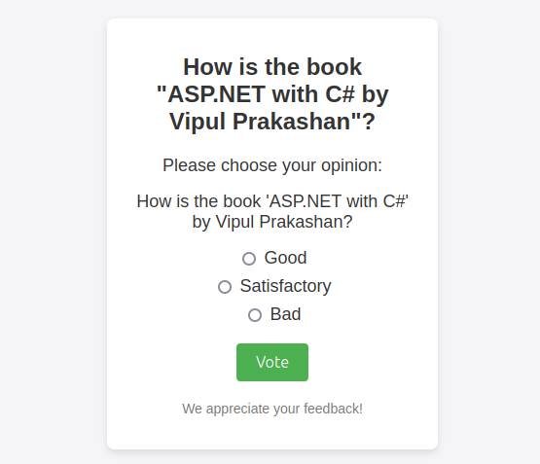  
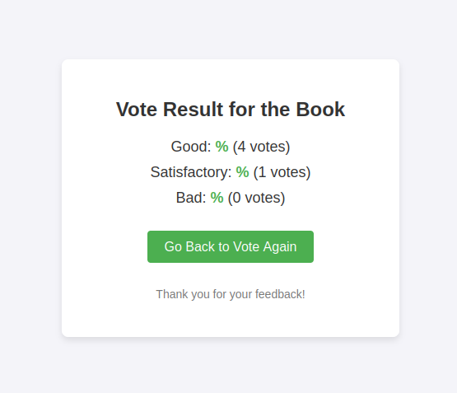

**3. Create a website with two pages. Page 1 has two TextBoxes (name and total marks) and one ‘Calculate’ Button as shown in the figure. On clicking the ‘Calculate’ Button, CGPA (total marks/50) along with the name should be displayed in the Page 2. Use Django sessions to store the information.**

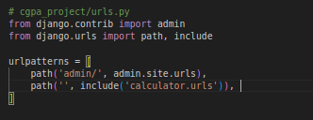

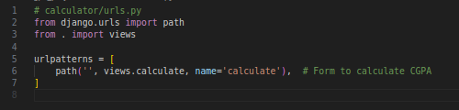

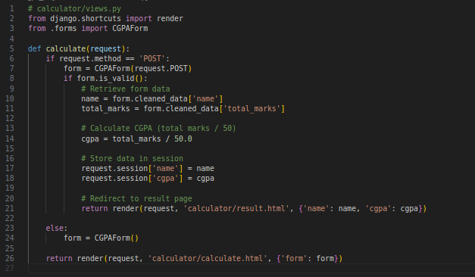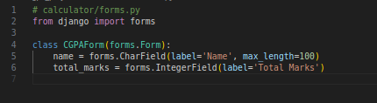

Calculate.html

